Professional Development Engagement Activity
This is a virtual event called CAREER MEET UP: STRATEGIES TO STAND OUT DURING THE JOB SEARCH. The event is about learning tips and tricks to grab recruiters’ attention. I attended this career meetup cause it’s my junior year and will be a senior soon. I attended to learn more on job searching and how to stand to get a higher chance of being accepted. This event helped, since Jessica(Presenter/Speaker) explained tips on preparing to apply for job/jobs like that you can use different customize resumes depending on company and career field. Also she was more in detail compared to presentations done during the ITSC 2600 sessions.

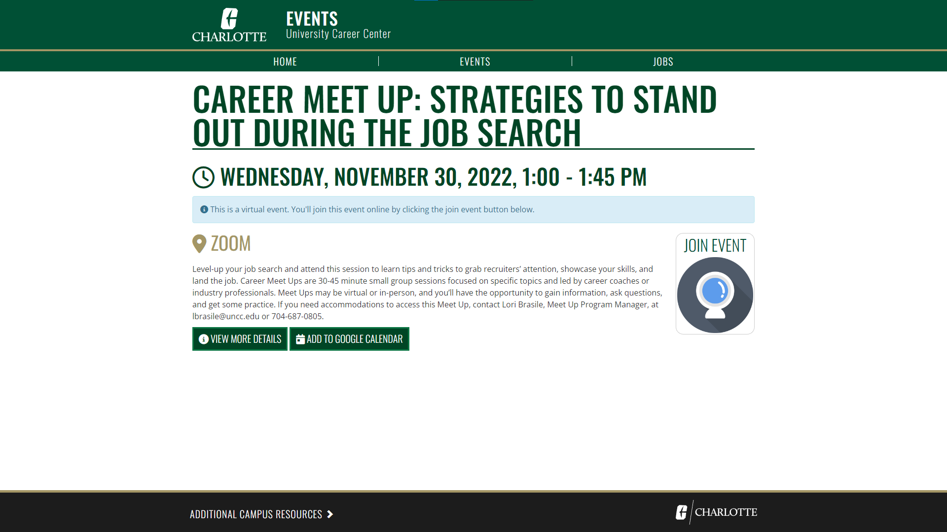
More Pictures below⬇️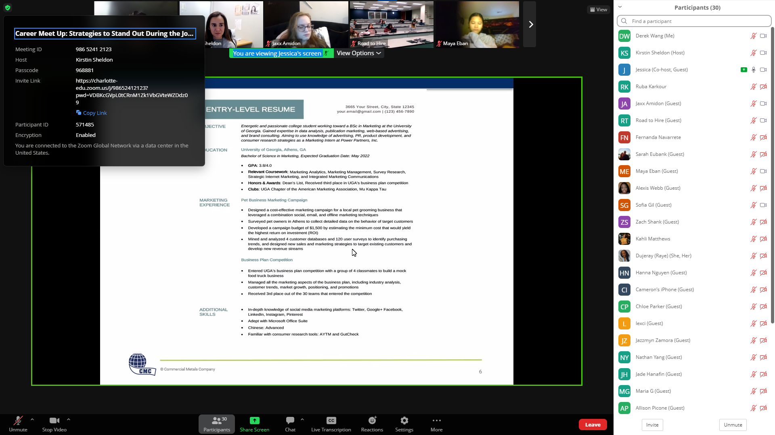
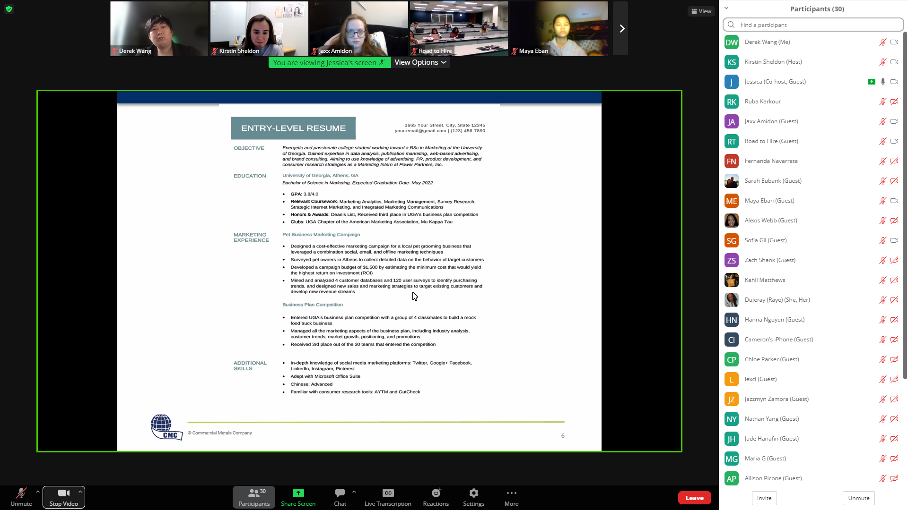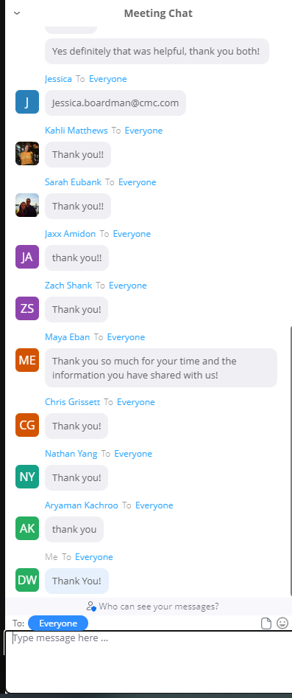End of zoom session

